

YENEPOYA INSTITUTE OF ARTS, SCIENCE, COMMERCE AND MANAGEMENT
A CONSTITUENT UNIT OF YENEPOYA (DEEMED TO BE UNIVERSITY)
BALMATTA, MANGALORE

INTERNSHIP REPORT
ON
DATA ANALYTICS

SUBMITTED BY
SHIVAKANTH V
VI SEMESTER
( BCA DATA SCIENCE AND BIG DATA ANALYTICS )

23BCDSBA78

UNDER THE GUIDANCE OF
MS. BHOOMIKA SUVARNA
LECTURER
DEPARTMENT OF COMPUTER SCIENCE

IN PARTIAL FULLFILLMENT OF THE REQUIREMENT
FOR THE AWARD OF THE DEGREE OF

BACHELOR OF COMPUTER APPLICATIONS

( DATA SCIENCE AND BIG DATA ANALYTICS )

MAY -2026

INTERNSHIP REPORT
ON
IMDB Top 1000 Movies Exploratory Data Analysis
Internship organization:


Austrix Technologies LLC
Middle East | Africa | India
Web: www.auStrix.com, Email: mailus@auStrix.com

Under the guidance of
Ms. Bhoomika Suvarna
Lecturer,
Department of Computer Science
Submitted by
Shivakanth V
23BCDSBA78

BACHELOR OF COMPUTER APPLICATION
(Data Science and Big Data Analytics)


YENEPOYA INSTITUTE OF ARTS, SCIENCE, COMMERCE & MANAGEMENT
(A constituent unit of Yenepoya Deemed to be University) Deralakatte, Mangaluru – 575018, Karnataka, India

CERTIFICATE

This is to certify that the project work entitled “Data Science and Big Data Analytics” has been successfully carried out at “Austrix Technologies LLC” by Shivakanth V (Reg. No. 23BCDSBA78), student of 3rd Year BCA (Data Science and Big Data Analytics) under the supervision and guidance of Ms. Bhoomika Suvarna, Lecturer, Department of Computer Science, Yenepoya Institute of Arts, Science, Commerce and Management. This dissertation is submitted in partial fulfilment for the award of degree in Bachelor of Computer Application by Yenepoya (Deemed to be university) during academic year 2025-26.

Internal Guide: Ms. Bhoomika Suvarna Chairperson

Internal Examiner: External Examiner

PRINCIPAL
Dr. Jeevan Raj
The Yenepoya Institute of Arts,
Science, Commerce and Management
(Deemed To be university)

Submitted for the viva-voice Place: Mangalore

Examination held on: Date:

DECLARATION

I, Shivakanth V a student of BCA (Data Science and Big Data Analytics) at Yenepoya Institute of Arts, Science, Commerce, and Management, Balmatta, Mangalore, affiliated with Yenepoya (Deemed to be University), hereby declare that this internship report titled IMDB Top 1000 Movies Exploratory Data Analysis is a genuine and original record of the work undertaken by me as part of my academic curriculum.
This report documents the knowledge, skills, and practical experience acquired during my internship at Austrix Technologies LLC. It includes methodologies, analytical processes, and investigative approaches aligned with recognized industry standards in digital forensics, incident response, and cybersecurity investigations.
I extend my sincere gratitude to Ms. Ayshath Lubna, Internship Program Head, for her valuable guidance, mentorship, and support throughout the internship period. I also express my appreciation to Austrix Technologies LLC for providing an enriching environment and exposure to real-world cybersecurity operations.
Furthermore, I acknowledge the support and encouragement received from my institutional guide,
Ms. Bhoomika Suvarna, and the faculty of Yenepoya Institute of Arts, Science, Commerce, and Management. Their insights and assistance have been instrumental in successfully completing this internship.
Intern Signature:  Name: Shivakanth V  Date:  Internship Supervisor Signature:  Name: Ms. Ayshath Lubna  Designation: Internship Program Head  Organization: Austrix Technologies LLC  Date: | Institution Guide Signature:  Name: Ms. Bhoomika Suvarna  Institute: Yenepoya Institute of Arts, Science, Commerce, and Management  Date:  Head of the Department (HOD) Signature:  Name: Dr. Rathnakar Shetty P  Head of Department of Computer Science  Institute: Yenepoya Institute of Arts, Science, Commerce, and Management  Date:

ACKNOWLEDGEMENT

I sincerely express my gratitude to Yenepoya Institute of Arts, Science, Commerce, and Management, affiliated with Yenepoya (Deemed to be University), Mangalore, for providing me with the opportunity to undertake this internship as part of my academic curriculum.
I extend my heartfelt thanks to Dr. Jeevan Raj, Principal, for his continuous support and guidance in facilitating this learning opportunity. I also express my sincere appreciation to Dr. Rathnakara Shetty P, Head of Department of Computer Science, for his encouragement and academic support throughout my internship journey.
I am deeply grateful to Ms. Ayshath Lubna for her visionary leadership and for fostering a dynamic learning environment in Austrix Technologies LLC. A special note of appreciation goes to Ms. Ayshath Lubna for her invaluable mentorship, expert guidance, and for sharing her vast experience in the field.
I also extend my sincere gratitude to Ms. Ayshath Lubna for their technical insights, hands-on training, and unwavering support during my internship. Their guidance has been instrumental in enhancing my practical understanding of cyber forensics and incident response methodologies.
I am also thankful to my internal guide, Ms. Bhoomika Suvarna, for her academic mentorship and for providing valuable insights that helped bridge the gap between theoretical learning and practical application.
Lastly, I am grateful to my faculty mentors, family, and peers for their encouragement and motivation throughout this journey.

Name: Shivakanth V
Reg NO: 23BCDSBA78
Date:

INTERNSHIP OFFER LETTER

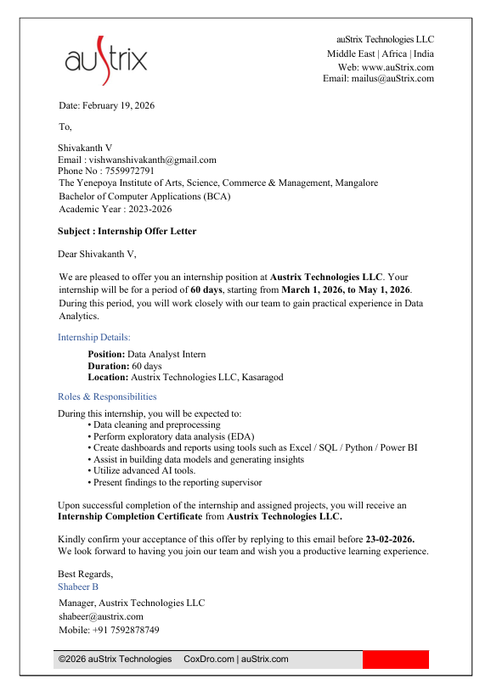
INTERNSHIP COMPLETION CERTIFICATE

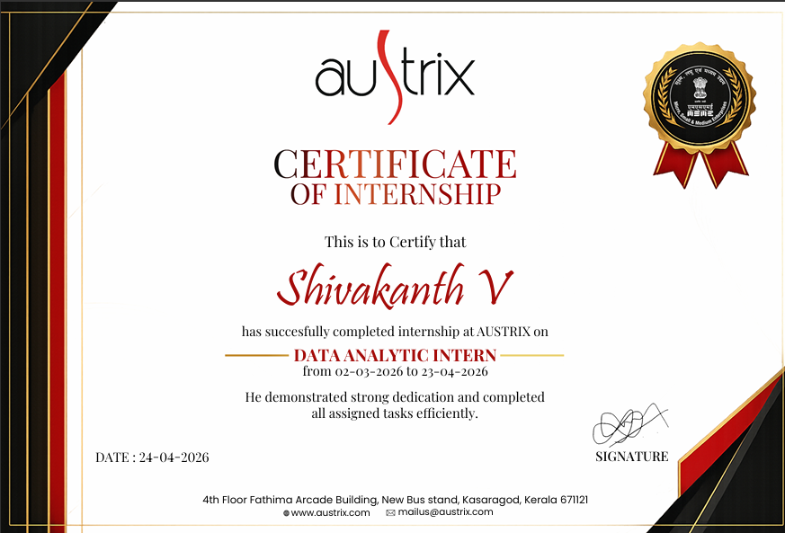

COMPANY PROFILE: [Austrix Technologies]
Website:www.austrix.com Founded: 1999
Headquarters: Canada
Support Centers: USA, UAE, India, Qatar
Overview:
Austrix Technologies is a global provider of enterprise-grade web hosting and IT infrastructure solutions. With over two decades of experience, the company delivers scalable, secure, and high- performance hosting environments tailored for businesses of all sizes.
Core Services:
- Web & Email Hosting – High-speed, secure hosting with spam protection, DKIM support, and mailbox migration tools.
- Domain Registration – Global domain registration with DNS management.
- Cloud Solutions & Dedicated Servers – Reliable, scalable hosting infrastructure with 99.9% uptime.
- Custom Solutions – Digital signage, enterprise mail services, and application hosting customized for business needs.
Key Features:
- 24/7 Global Support
- Data Redundancy & Daily Backups
- Real-time Monitoring & Performance Dashboards
- Multi-layer Security (network, host, application)
- Disaster Recovery & RAID Technology

Why Austrix:
- Proven track record of reliable service delivery
- Infrastructure spread across continents

- Strong emphasis on data protection and uptime
Contact: Visit: www.austrix.com/contact-us.aspx

ROLES AND RESPONSIBILITIES

During the project, I was actively involved in performing end-to-end data analysis on the IMDB Top 1000 Movies dataset using Python. My key roles and responsibilities included:

Data Collection and Understanding
- Imported and worked with the IMDB Top 1000 dataset using Python (Pandas)
- Explored dataset structure using functions like .info(), .head(), and .describe()
- Identified important features such as IMDB Rating, Number of Votes, Gross Earnings, Genre, Director, Actors, Runtime, and Released Year
- Understood the significance of each variable to guide the analysis process
Data Cleaning and Preprocessing
- Checked for missing values using .isnull().sum() and ensured data consistency
- Cleaned and converted the Gross column into numeric format
- Converted Runtime from text into integer format
- Verified and corrected data types for accurate analysis
- Handled missing values in Gross and Meta_score using mean imputation
- Performed data transformation for better analysis and visualization
- Extracted and organized genre information for genre-wise analysis
Exploratory Data Analysis (EDA)
- Analyzed ratings distribution among top movies
- Identified top-rated and most popular movies based on votes
- Analyzed highest grossing movies and longest movies
- Studied genre distribution and average ratings across genres
- Identified top actors and directors based on frequency and performance
- Examined movie release trends across years
Data Visualization
- Created visualizations using Matplotlib and Seaborn to represent insights clearly
- Built:
- Bar charts for top-rated movies, top actors, and directors
- Horizontal bar charts for most popular movies
- Pie charts for gross revenue distribution
- Line plots for release year trends
- Scatter plots for relationship between votes and ratings
- Heatmaps for correlation analysis

Power BI Dashboard Development
Designed and developed an interactive one-page Power BI dashboard for movie analysis
- Created KPI cards for:
- Total Movies
- Average Rating
- Total Votes
- Total Gross Revenue
- Average Runtime
- Developed interactive visualizations including:
- Top-rated movies analysis
- Most popular movies analysis
- Genre distribution charts
- Director and actor performance analysis
- Gross revenue analysis
- Release year trend analysis
- Correlation matrix visualization
- Added filters and slicers for:
- Genre
- Release Year
- Certificate
- Applied dashboard formatting, themes, and layout customization to improve readability and user interaction

Trend and Relationship Analysis
- Analyzed trends in movie releases across years
- Studied genre-wise patterns and rating behavior
- Examined relationship between popularity (votes) and gross earnings
- Analyzed correlations among ratings, votes, gross revenue, and meta scores
- Evaluated factors influencing movie success and audience engagement

Insight Generation and Reporting
- Identified key findings such as dominance of Drama genre in the dataset
- Highlighted top-performing actors, directors, and highest-rated movies
- Interpreted how audience popularity influences revenue generation
- Explained trends related to genres, release years, and movie success
- Prepared clear, structured reports and visual insights for presentation
- Presented findings using both Python visualizations and Power BI dashboards for better understanding

Tools and Technologies Used
- Python
- Pandas
- NumPy
- Matplotlib
- Seaborn
- Microsoft Power BI
- Jupyter Notebook

Outcome of the Project
- Gained practical experience in real-world data analysis and dashboard development
- Developed skills in data cleaning, visualization, and interactive reporting
- Improved analytical thinking and interpretation of business-style insights
- Successfully transformed raw movie data into meaningful insights using Python and Power BI
- Enhanced presentation and storytelling skills through dashboard-based reporting

LEARNING OUTCOMES

This project provided a valuable opportunity to apply theoretical knowledge of data analytics to a real-world movie dataset. Working on the IMDB Top 1000 Movies analysis helped me understand how raw data can be transformed into meaningful insights about movie ratings, popularity, revenue, genres, and factors influencing success.

Throughout this project, I gained both technical and analytical skills, along with a deeper understanding of how data-driven insights can support informed decision-making. I also gained practical exposure to dashboard development using Microsoft Power BI for interactive data visualization and reporting.

1. Understanding the Importance of Data Cleaning and Preparation

One of the most important lessons I learned during this project was the significance of data cleaning and preprocessing. Although the dataset was structured, it still required careful handling to ensure accuracy.

For example:

- The Gross column contained commas and needed conversion into numeric format
- The Runtime column had to be cleaned and converted into integer values
- Missing values in Gross and Meta_score were handled using mean imputation
- Data consistency and correct data types were verified before analysis

This experience taught me that data preprocessing is a critical step, because without proper cleaning, analysis results may become inaccurate or misleading.

2. Developing Strong Exploratory Data Analysis (EDA) Skills

This project helped me build a strong foundation in Exploratory Data Analysis (EDA), which is essential for identifying patterns and trends.

I explored the dataset by:
- Analyzing ratings distribution across movies
- Identifying top-rated and most popular movies based on votes
- Studying genre distribution and release year trends
- Identifying top-performing actors and directors
- Comparing box office earnings among movies

Through this process, I discovered that audience popularity strongly influences movie success and that certain genres, actors, and directors dominate the dataset.

EDA helped me understand how to explore data effectively, ask relevant questions, and extract meaningful insights.

3. Data Visualization and Interpretation

Another important learning outcome was representing data visually using Matplotlib and Seaborn.

I created various visualizations such as:

- Bar charts for top movies, actors, and directors
- Line charts for movie release trends
- Pie charts for gross revenue distribution
- Scatter plots to study votes vs ratings relationship
- Heatmaps to analyze correlations among variables

These visualizations made it easier to interpret complex data and communicate findings clearly.

I learned that effective visualization is essential for storytelling with data, especially when presenting insights to both technical and non-technical audiences.

4. Power BI Dashboard Development

One of the major skills I developed during this project was creating an interactive dashboard using Microsoft Power BI.

I learned how to:

- Design a one-page movie analytics dashboard
- Create KPI cards for ratings, votes, runtime, and gross revenue
- Build interactive charts and visualizations
- Add filters and slicers for genre, release year, and certificate
- Organize dashboard layouts for better readability and user interaction

The dashboard helped transform complex movie data into an interactive and visually appealing reporting system.

This experience improved my understanding of business intelligence tools and real-time analytical reporting.

5. Understanding Relationships Between Variables

One of the most valuable insights from this project was understanding relationships between variables.

Through analysis and correlation study, I observed:

- A strong positive relationship between Number of Votes and Gross Earnings
- A moderate relationship between Ratings and Votes
- Popular movies often generate higher revenue

I also studied release year trends and genre-wise rating patterns.

This helped me understand how different variables interact and influence overall movie performance.

6. Analytical Thinking and Insight Generation

This project significantly improved my analytical thinking skills.
Instead of only generating graphs, I learned to:

- Interpret results logically
- Connect findings to real-world industry scenarios
- Explain reasons behind patterns and trends

For example:

- High votes often indicate strong audience engagement, which can lead to higher earnings
- Drama dominates in quantity, while Western has higher average ratings, showing quality versus quantity
- Frequent appearances of certain actors and directors highlight their influence on successful films

This strengthened my ability to convert raw data into meaningful and actionable insights.

7. Communication and Presentation Skills

An important part of this project was presenting findings in a clear and structured manner.

I learned how to:

- Organize reports logically
- Write conclusions in a simple and understandable way
- Present technical insights clearly
- Explain analytical results during presentations and viva sessions
- Present insights effectively using Power BI dashboards and visual reports

This improved my confidence in communicating data insights effectively.

Overall Learning Experience

Overall, this project enhanced my technical knowledge, analytical thinking, visualization skills, and reporting abilities. It provided practical exposure to real-world data analysis using Python and Power BI, and strengthened my confidence in handling data-driven projects and presenting meaningful insights effectively.

WEEKLY INTERNSHIP LOG

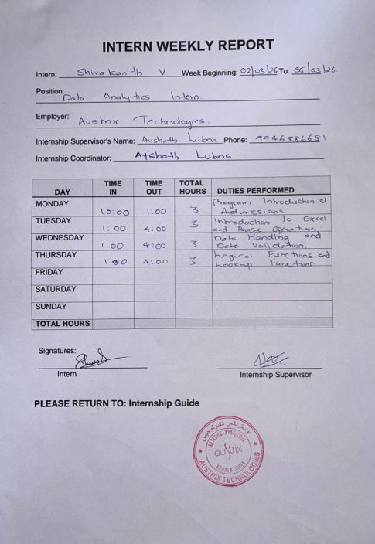
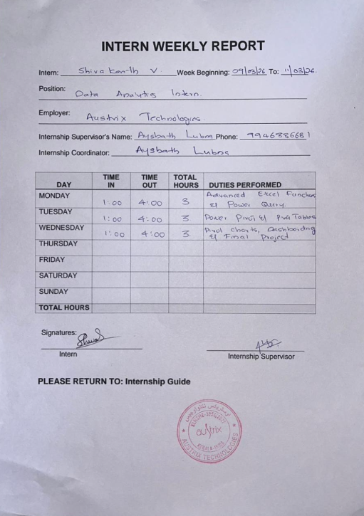

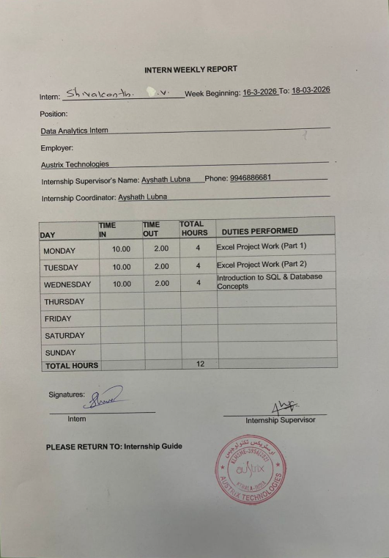

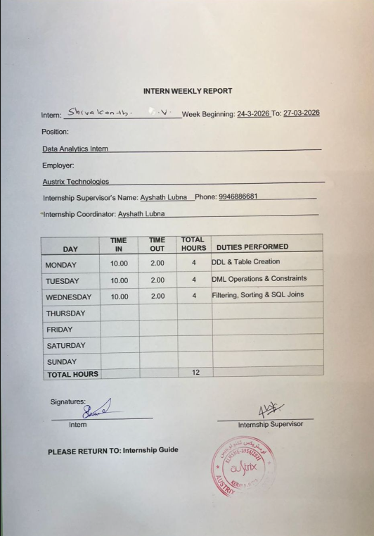
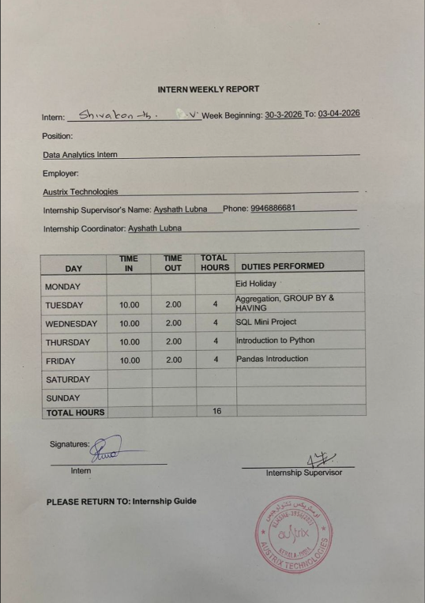
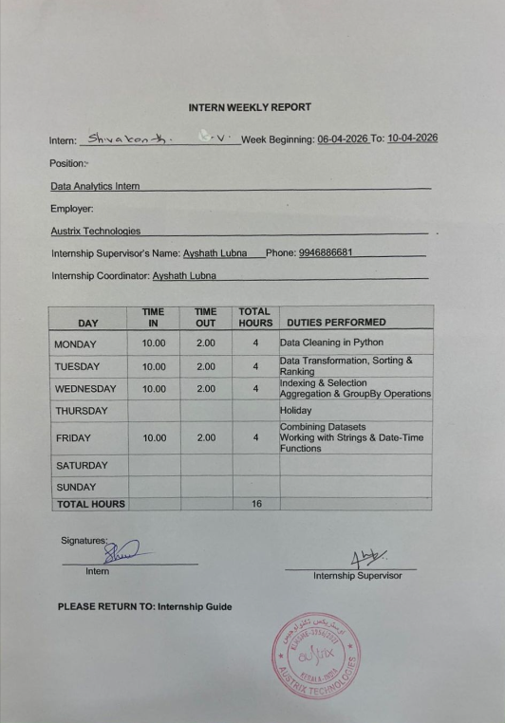

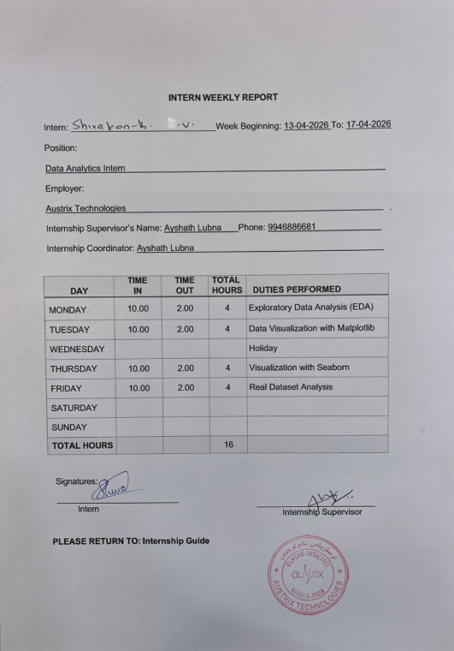
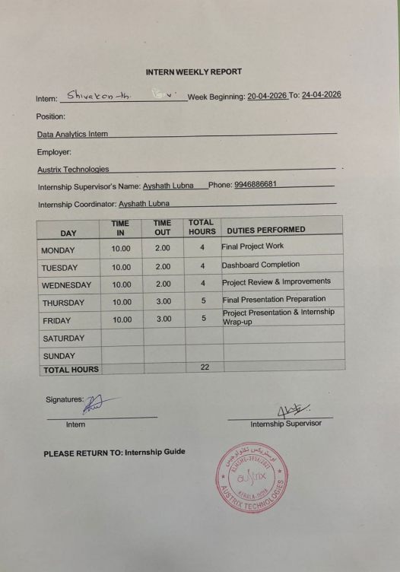
CERTIFICATIONS & OTHER ACTIVITIES

During the Data Analytics project, I successfully completed a structured and practical analysis workflow that provided hands-on experience in data preprocessing, exploratory data analysis, visualization, and dashboard development. The project followed a step-by-step analytical approach using Python libraries and Microsoft Power BI, enabling me to work with a real-world movie dataset and derive meaningful insights.

In the initial phase, I worked with the IMDB Top 1000 Movies dataset using Python and Pandas. I explored the dataset structure using functions such as .head(), .info(), and .describe() to understand the data and identify important fields like IMDB Rating, Number of Votes, Gross Earnings, Genre, Runtime, Directors, Actors, and Release Year.

During the data preprocessing stage, I performed data cleaning and transformation to ensure accuracy and consistency. The Gross column was cleaned and converted into numeric format, while the Runtime column was transformed into integer values for analysis. Missing values in Gross and Meta_score were handled using mean imputation, and all data types were verified and corrected for accurate computations and visualization.

In the exploratory data analysis (EDA) phase, I analyzed movie ratings, popularity, genres, actors, directors, runtime, release trends, and box office performance. I identified top-rated movies, most popular movies based on votes, highest grossing films, and longest movies in the dataset. I also performed genre-wise and director-wise analysis to understand patterns influencing movie success.

Further, I created visualizations using Matplotlib and Seaborn, including:

- Bar charts for top-rated movies, actors, and directors
- Horizontal bar charts for most popular movies
- Pie charts for gross revenue distribution
- Line charts for release year trends
- Scatter plots for votes vs ratings analysis
- Heatmaps for correlation analysis

These visualizations helped in understanding relationships among variables and communicating insights effectively.

As part of the project, I also developed an interactive dashboard using Microsoft Power BI. The dashboard included KPI cards, genre analysis, top movie analysis, actor and director performance, gross revenue insights, and trend visualizations. Interactive slicers and filters were added to improve user interaction and dashboard usability.

Through this project, I identified important insights such as:

- The strong relationship between audience votes and gross earnings
- The dominance of Drama genre in the dataset
- The influence of actors and directors on movie success
- Trends in movie releases across years
- The role of audience popularity in commercial success

This project helped me apply practical data analytics concepts to a real-world dataset and transform raw movie data into meaningful insights and interactive reports.

Overall, the project strengthened my skills in data analysis, visualization, dashboard creation, problem-solving, and insight generation. It also improved my confidence in working with real-world datasets and presenting analytical findings in a structured and professional manner.

ABSTRACT

In today’s data-driven world, analyzing movie and audience data plays an important role in understanding trends, popularity, and the factors influencing success in the entertainment industry. This project focuses on performing an in-depth analysis of the IMDB Top 1000 Movies dataset to understand patterns related to movie ratings, audience engagement, genres, revenue, directors, actors, and overall movie performance.

The dataset used in this project contains information such as IMDB ratings, number of votes, gross earnings, genres, directors, actors, runtime, certificates, and release years. Using Python and data analysis libraries such as Pandas, NumPy, Matplotlib, and Seaborn, the dataset was cleaned, processed, and analyzed to extract meaningful insights. Different analytical techniques including data preprocessing, grouping, aggregation, trend analysis, correlation analysis, and visualization were applied to identify patterns and relationships within the dataset.

The project also involved the development of an interactive dashboard using Microsoft Power BI to present insights visually and improve interpretability. The dashboard included KPI cards, genre analysis, top-rated movies, actor and director analysis, revenue analysis, and trend visualizations with interactive filters and slicers.

The analysis revealed several important insights. Drama emerged as the most dominant genre in the dataset, while movies such as The Shawshank Redemption, The Godfather, and The Dark Knight stood out as highly rated and popular films. The study also highlighted the strong influence of actors and directors on movie success, along with increasing representation of highly rated movies in recent years.

One of the most significant findings from the analysis was the strong positive relationship between audience votes and gross earnings, indicating that audience popularity plays a major role in commercial success. The project also showed how factors such as genre, release year, runtime, and audience engagement contribute to overall movie performance.

Overall, this project demonstrates how data analytics and visualization techniques can effectively transform raw movie data into meaningful insights. The findings help in understanding audience behavior, movie success factors, and entertainment industry trends, while also showcasing how data-driven approaches can support informed analysis and decision-making.

Table of context

Sl.no | Topic | Page No
1. | CHAPTER 1 : INTRODUCTION | 1-3
1.1 | Background
1.2 | Objectives
1.3 | Purpose
1.4 | Scope
1.5 | Data Sources
1.6 | Problem Definition
2. | CHAPTER 2: TOOLS AND TECHNOLOGY USED | 4-7
3. | CHAPTER 3: DATA COLLECTION AND ANALYSIS | 8-11
3.1 | Data Collection
3.2 | Data preprocessing
3.3 | Feature Engineering
3.4 | Exploratory Data Analysis
4. | CHAPTER 4: SYSTEM REQUIREMENTS AND ANALYSIS | 12-15
4.1 | System Requirements Specification
4.1.1 | Functional Requirements
4.1.2 | Non-Functional Requirements
4.2 | Hardware and software Requirements
4.3 | System Overview
5. | CHAPTER 5: IMPLEMENATION | 16-21
5.1 | System Design/Algorithms
5.2 | Workflow/Process Diagrams
5.3 | Module Description
5.4 | Project Screenshots | 22-35
5.5 | Report on Analysis | 37-38
5.6 | Final Insights | 39-40
6. | CHAPTER 6: FUTURE SCOPE AND CONCLUSION | 41
7. | Bibliography | 42
8. | Conclusion | 43
9. | Remarks | 44

List of Figures

Fig no. | Description | Page No.
1 | Microsoft PowerBI dashboard | 22
2 | Importing required libraries and loading the dataset | 23
3 | Initial Data Exploration | 24
4 | Data Preprocessing | 25
5 | Top Rated Movies Analysis | 26
6 | Top Actors Analysis | 27
7 | Most Popular Movies Analysis (Based on Votes) | 28
8 | Longest Movies Analysis | 29
9 | Highest Grossing Movies Analysis | 30
10 | Genre Distribution Analysis | 31
11 | Genre-wise Rating Analysis | 32
12 | Movie Release Year Trend Analysis | 33
13 | Certificate-wise Analysis | 34
14 | Director Analysis | 35
15 | Correlation Analysis | 36

CHAPTER 1: INTRODUCTION

1.1 Background
With the rapid growth of digital entertainment platforms, online streaming services, and global cinema audiences, the movie industry generates massive amounts of data related to ratings, audience engagement, genres, actors, directors, and box office collections. Analyzing this data is important for understanding movie performance, audience preferences, and the factors that influence commercial and critical success.

Data analytics plays a major role in transforming raw movie data into meaningful insights by identifying patterns, trends, and relationships among variables. By studying ratings, popularity, revenue, genres, and release trends, it becomes possible to understand how different elements contribute to movie success and audience engagement.

This project focuses on analyzing the IMDB Top 1000 Movies dataset using Python and visualization techniques to gain insights into movie performance and industry trends.

1.2 Objectives
- To analyze movie ratings and popularity using the IMDB Top 1000 dataset
- To identify top-rated, most popular, and highest grossing movies
- To compare performance across genres, directors, and actors
- To study release year trends and runtime patterns
- To analyze the relationship between audience votes and gross earnings
- To identify factors influencing movie success and audience engagement
- To create visualizations and an interactive dashboard for better understanding of movie data

1.3 Purpose
The purpose of this project is to extract meaningful insights from movie-related data and understand how factors such as ratings, popularity, genres, directors, actors, and revenue influence movie performance and success.

The project also aims to demonstrate how data analytics and visualization techniques can be used to analyze entertainment industry data and support data-driven understanding of audience behavior and movie trends.
1.4 Scope
This project focuses on analyzing movie data using Python and Microsoft Power BI. The scope of the project includes:

- Data cleaning and preprocessing
- Handling missing values and data transformation
- Exploratory Data Analysis (EDA)
- Correlation and trend analysis
- Data visualization using charts and graphs
- Dashboard development using Power BI
- Insight generation from movie-related metrics

The analysis is limited to the IMDB Top 1000 Movies dataset and focuses mainly on structured movie data.

1.5 Data Sources
IMDB Top 1000 Movies Dataset (CSV File)

The dataset contains important movie-related fields such as:
- Series Title
- IMDB Rating
- Number of Votes
- Gross Earnings
- Genre
- Director
- Actors (Star1, Star2, Star3, Star4)
- Runtime
- Released Year
- Meta Score
- Certificate
The dataset was used for preprocessing, analysis, visualization, and dashboard creation.

1.6 Problem Definition
The main problem addressed in this project is identifying the key factors that influence movie success and audience engagement.

Specifically, the project focuses on understanding:

- How audience votes influence gross earnings
- Which genres perform better in terms of ratings and popularity
- The impact of directors and actors on movie success
- Trends in movie releases across different years
- Relationships among ratings, popularity, runtime, and revenue

The project also addresses challenges such as handling missing values, converting data types, and transforming raw movie data into a structured format suitable for analysis and visualization.

CHAPTER 2: TOOLS AND TECHNOLOGY USED
The successful completion of this IMDB Top 1000 Movies Analysis project was made possible through the effective use of various tools, technologies, and data analysis libraries. These tools helped in data preprocessing, analysis, visualization, and dashboard development, enabling meaningful insights to be extracted from the dataset.

1. Programming Languages and Libraries
- Python
Python served as the core programming language for this project because of its simplicity, flexibility, and strong support for data analysis and visualization. It was used for:

- Data preprocessing
- Exploratory Data Analysis (EDA)
- Data transformation
- Statistical analysis
- Visualization and insight generation
Python helped in efficiently handling and analyzing the movie dataset.

- Pandas
Pandas played a major role in handling and analyzing the IMDB dataset. It was used for:

- Loading the dataset using read_csv()
- Performing data cleaning and preprocessing
- Handling missing values
- Converting and cleaning Gross and Runtime columns
- Performing aggregation using groupby()
- Analyzing actors, directors, genres, and movie performance
- Sorting and filtering data using functions like sort_values() and nlargest()
- Creating transformed columns for analysis

Pandas made data manipulation simple, efficient, and organized.

- NumPy
NumPy was used for numerical and statistical computations. It helped in:

- Numerical calculations
- Statistical operations
- Supporting data transformations
- Efficient handling of numerical data
- Working with arrays and mathematical functions
NumPy improved performance and simplified numerical analysis tasks.

- Matplotlib
Matplotlib was used for creating basic and informative visualizations. It was used to generate:

- Bar charts
- Pie charts
- Line graphs
- Scatter plots
- Runtime and trend visualizations
These charts helped in visually understanding movie trends and performance patterns

- Seaborn
Seaborn was used for advanced and visually appealing statistical visualizations. It was mainly used for:

- Bar plots
- Scatter plots
- Correlation heatmaps
- Distribution analysis
- Trend analysis visualizations
Seaborn improved the clarity and presentation quality of the analysis.

2. Business Intelligence Tool

Microsoft Power BI

Power BI was used to create an interactive one-page dashboard for movie analysis and reporting. It helped in transforming analytical results into interactive visual insights.

Power BI was used for:

- Creating KPI cards
- Designing interactive dashboards
- Building charts for movie analysis
- Creating filters and slicers
- Visualizing ratings, votes, genres, revenue, actors, and directors
- Presenting insights in an organized and user-friendly format

The dashboard improved data presentation, interaction, and overall understanding of the analysis.

- Development Environment

Jupyter Notebook

Jupyter Notebook was used as the primary development environment for the project. It allowed:

- Writing and executing Python code step-by-step
- Visualizing outputs instantly
- Combining code, charts, and explanations together
- Performing analysis in an organized and interactive manner

It made the overall workflow easier to manage and understand.

Excel

Excel was initially used for:

- Previewing the dataset
- Understanding column structures and data types
- Performing basic validation and inspection before analysis in Python

Excel helped in obtaining a quick overview of the dataset before preprocessing and analysis.

- Technologies Used Summary

Tool / Technology Purpose
Python Core programming language
Pandas Data cleaning and analysis
NumPy Numerical computations
Matplotlib Basic visualizations
Seaborn Advanced visualizations
Power BI Interactive dashboard development
Jupyter Notebook Development environment
Excel Initial dataset inspection

- Conclusion

The combination of Python libraries, visualization tools, and Power BI provided a complete environment for performing movie data analysis effectively. These technologies helped in transforming raw IMDB movie data into meaningful insights, visual reports, and interactive dashboards, making the analysis more accurate, efficient, and easy to understand.

CHAPTER 3: DATA COLLECTION AND ANALYSIS

3.1 Data Collection
The dataset used for this project was collected in CSV format and contains detailed information about the IMDB Top 1000 Movies. The dataset includes various movie-related attributes that help analyze movie performance, audience engagement, and commercial success.

The dataset contains fields such as:

- IMDB Ratings
- Number of Votes
- Gross Earnings
- Genres
- Directors
- Actors
- Runtime
- Released Year
- Meta Score
- Certificate

This dataset was used as the primary source for data preprocessing, exploratory data analysis, visualization, and dashboard development.

3.2 Data Preprocessing
Data preprocessing was an important step to ensure accuracy, consistency, and reliability of the analysis.
The following preprocessing tasks were performed:
- Handled missing values and verified dataset completeness
- Converted the Gross column into numeric format by removing commas
- Converted the Runtime column from text format into integer values
- Handled missing values in Gross and Meta_score using mean imputation
- Cleaned inconsistent entries and standardized data formats
- Verified and corrected data types for accurate computations
- Checked for duplicate records where necessary
- Prepared the dataset for analysis and visualization

These preprocessing steps improved data quality and ensured reliable analytical results.

3.3 Feature Engineering

Feature engineering was performed to improve analysis and simplify comparisons across different movie categories.

The following transformations and derived features were created:

- Extracted Main Genre from the multi-genre column for genre-wise analysis
- Aggregated data by genre, actors, directors, and release year
- Created summary metrics such as:
- Average IMDB Ratings
- Total Gross Earnings
- Total Votes
- Top Gross Collections
- Top Movie Counts
- Transformed data into formats suitable for comparison and visualization
- Organized actor and director data for performance analysis

These engineered features helped in identifying trends and generating meaningful insights.

3.4 Exploratory Data Analysis
Exploratory Data Analysis was performed to identify patterns, trends, and relationships within the dataset.

Key Findings
- The Shawshank Redemption is the highest-rated movie with an IMDB rating of 9.3 and is also one of the most popular movies based on audience votes.
- Drama is the most common genre in the dataset, indicating its dominance in highly rated movies.
- Western genre has the highest average rating, showing strong quality despite having fewer movies.
- Robert De Niro appears in the highest number of movies among actors in the dataset.
- Alfred Hitchcock directed the highest number of films among all directors.
- Release year analysis shows that recent years such as 2014, 2004, and 2009 contain a large number of top-rated movies.
- Commercially successful movies such as Star Wars: The Force Awakens, Avengers: Endgame, and Avatar generated the highest gross earnings.
- Ratings, popularity, genres, actors, and directors all contribute significantly to movie success.

Major Insight

One of the most important insights identified during the analysis was the strong relationship between Number of Votes and Gross Earnings.

This relationship indicates:

Higher Votes → Higher Popularity → Higher Gross Revenue

This shows that audience engagement and popularity play a major role in determining the commercial success of movies.

The analysis also revealed:

- A moderate positive relationship between IMDB Ratings and Votes
- Popular movies generally generate higher revenue
- Audience response has stronger influence on commercial performance than critic scores alone

These findings highlight the importance of audience engagement in the entertainment industry.

3.5 Visualization and Dashboard Analysis

To better understand the dataset and present insights effectively, multiple visualizations were created using Matplotlib, Seaborn, and Microsoft Power BI.

The visual analysis included:

- Bar charts for top-rated movies, actors, and directors
- Horizontal bar charts for most popular movies
- Pie charts for gross revenue distribution
- Line charts for movie release trends
- Scatter plots for votes vs ratings analysis
- Heatmaps for correlation analysis

An interactive Power BI dashboard was also developed to display:

- KPI cards for ratings, votes, runtime, and gross earnings
- Genre analysis
- Top movie analysis
- Actor and director performance
- Revenue insights
- Trend analysis with filters and slicers

These visualizations helped transform raw movie data into meaningful and easy-to-understand insights.

CHAPTER 4: SYSTEM REQUIREMENTS AND ANALYSIS

4.1 System Requirements Specification
4.1.1 Functional Requirements
The system should be capable of performing the following functions:

- Load the IMDB Top 1000 Movies dataset
- Perform data preprocessing and cleaning
- Handle missing values and data transformation
- Analyze movie ratings, popularity, genres, and revenue trends
- Perform exploratory data analysis (EDA)
- Generate visualizations and statistical insights
- Analyze actors, directors, runtime, and release trends
- Identify important movie success patterns
- Create an interactive dashboard using Microsoft Power BI
- Present insights in a structured and understandable format

4.1.2 Non-Functional Requirements
The system should satisfy the following non-functional requirements:

- Efficient data processing and analysis
- Accurate and reliable analytical results
- Clear and easy-to-understand visualizations
- User-friendly dashboard and reporting interface
- Scalability for handling larger movie datasets
- Organized and maintainable analysis workflow

4.2 Hardware & Software Requirements
- Hardware Requirements
- Laptop/Desktop Computer
- Minimum 4GB RAM
- Intel i3 Processor or above
- Stable storage for dataset and project files

- Software Requirements
- Python
- Jupyter Notebook
- Microsoft Power BI
- Microsoft Excel
- Python Libraries Used
  - Pandas
  - NumPy
  - Matplotlib
Seaborn These libraries were used for preprocessing, data analysis, visualization, and insight generation.

4.3 System Overview
The system is designed to analyze movie-related data using a structured analytical workflow. It transforms raw IMDB movie data into meaningful insights through preprocessing, analysis, visualization, and dashboard reporting.

System Workflow
- Import the IMDB dataset
- Clean and preprocess the data
- Handle missing values and transform columns
- Perform Exploratory Data Analysis (EDA)
- Create charts and visualizations
- Perform correlation and trend analysis
- Build an interactive Power BI dashboard
- Generate insights and conclusions

This workflow ensures that raw movie data is systematically converted into understandable and meaningful analytical insights.

4.4 System Analysis

The analysis system focuses on understanding movie performance and identifying factors influencing success. The system evaluates:

- Movie ratings and audience popularity
- Genre-wise performance
- Actor and director contribution
- Gross earnings and commercial success
- Release year trends
- Relationships between votes, ratings, and revenue

The system also uses visualizations and dashboard analytics to simplify interpretation and improve presentation of results.

4.5 Output of the System
The system generates:

- Cleaned and processed movie dataset
- Statistical summaries and analysis reports
- Graphical visualizations and trend analysis
- Correlation analysis results
- Interactive Power BI dashboard
- Final insights and conclusions about movie success patterns

The final output helps in understanding audience behavior, popularity trends, and factors contributing to successful movies in the entertainment industry.

CHAPTER 5: IMPLEMENTATION

5.1 System Design

The system was designed to perform complete movie data analysis in a structured and organized manner. The implementation process transforms raw IMDB movie data into meaningful insights through preprocessing, analysis, visualization, and dashboard reporting.

Input
- IMDB Top 1000 Movies Dataset (CSV File)

The dataset contains movie-related information such as:

- Ratings
- Votes
- Gross Earnings
- Genres
- Directors
- Actors
- Runtime
- Released Year
- Meta Score

Process

The implementation process follows the workflow:

Data Cleaning → Data Analysis → Data Visualization → Dashboard Development → Insight Generation

The system processes raw movie data step-by-step to identify patterns, trends, and relationships influencing movie success.

Output

The system generates:

Cleaned and processed dataset
Statistical analysis results
Visual charts and graphs
Correlation analysis
Interactive dashboard using Microsoft Power BI
Movie insights and conclusions

The final output helps in understanding audience behavior, popularity trends, and movie performance factors.

5.2 Workflow

The implementation workflow followed a systematic analytical process to ensure accurate and meaningful results.

1. Data Loading

The IMDB dataset was imported into Python using the Pandas library.

Tasks performed:

- Reading CSV file using read_csv()
- Exploring dataset structure using .head(), .info(), and .describe()
- Understanding columns and data types

2. Data Cleaning

Data preprocessing and cleaning were performed to improve dataset quality.

Tasks performed:

- Handling missing values
- Cleaning the Gross column and converting it into numeric format
- Converting Runtime into integer format
- Correcting inconsistent entries
- Verifying and correcting data types
- Standardizing data formats for analysis

This step ensured accurate computations and reliable analysis.

3. Exploratory Data Analysis (EDA)

EDA was performed to identify patterns, trends, and relationships within the dataset.

Analysis included:

- Top-rated movies analysis
- Most popular movies based on votes
- Highest grossing movies
- Genre-wise movie analysis
- Actor and director analysis
- Runtime analysis
- Release year trends
- Correlation analysis between variables

This helped in identifying key movie success factors.

4. Visualization

Data visualizations were created using Matplotlib and Seaborn to represent insights clearly and effectively.

Visualizations created:

- Bar charts
- Horizontal bar charts
- Pie charts
- Line graphs
- Scatter plots
- Correlation heatmaps

These charts simplified interpretation of complex movie data.

5. Dashboard Development

An interactive dashboard was developed using Microsoft Power BI to present analytical insights visually.

Dashboard features included:

- KPI cards
- Genre analysis
- Ratings and popularity analysis
- Actor and director performance
- Gross earnings analysis
- Trend visualizations
- Interactive filters and slicers

The dashboard improved user interaction and data presentation.

6. Insight Generation

The final step involved interpreting the analysis results and generating meaningful conclusions.

Key insights generated:

- Audience popularity strongly influences gross earnings
- Drama dominates the dataset in quantity
- Western genre has high average ratings
- Certain actors and directors contribute significantly to successful movies
- Recent years contain a large number of highly rated films

These insights helped in understanding movie success and audience engagement patterns.

5.3 Modules

The project implementation was divided into different modules for better organization and execution.

Data Preprocessing Module

This module handled:

- Loading the dataset
- Cleaning and transforming data
- Handling missing values
- Correcting data types
- Preparing data for analysis
- Analysis Module

This module performed:

- Exploratory Data Analysis (EDA)
- Statistical analysis
- Correlation analysis
- Genre, actor, and director analysis
- Popularity and revenue analysis
Visualization Module

This module generated:

- Charts and graphical representations
- Correlation heatmaps
- Trend analysis graphs
- Dashboard visualizations using Power BI

The module helped in presenting analytical insights clearly and interactively.

5.4 Implementation Outcome

The implementation successfully transformed raw IMDB movie data into meaningful analytical insights through preprocessing, analysis, visualization, and dashboard reporting.

The project demonstrated how Python and Power BI can be effectively used together to analyze entertainment industry data and present findings in a structured and visually understandable format.

  - PROJECT SCREENSHOT

- Microsoft PowerBI dashboard

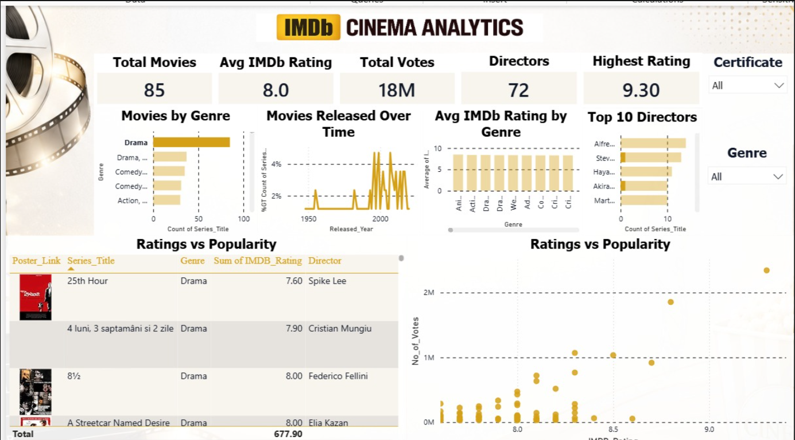

Fig no.1

- Importing required libraries and loading the dataset

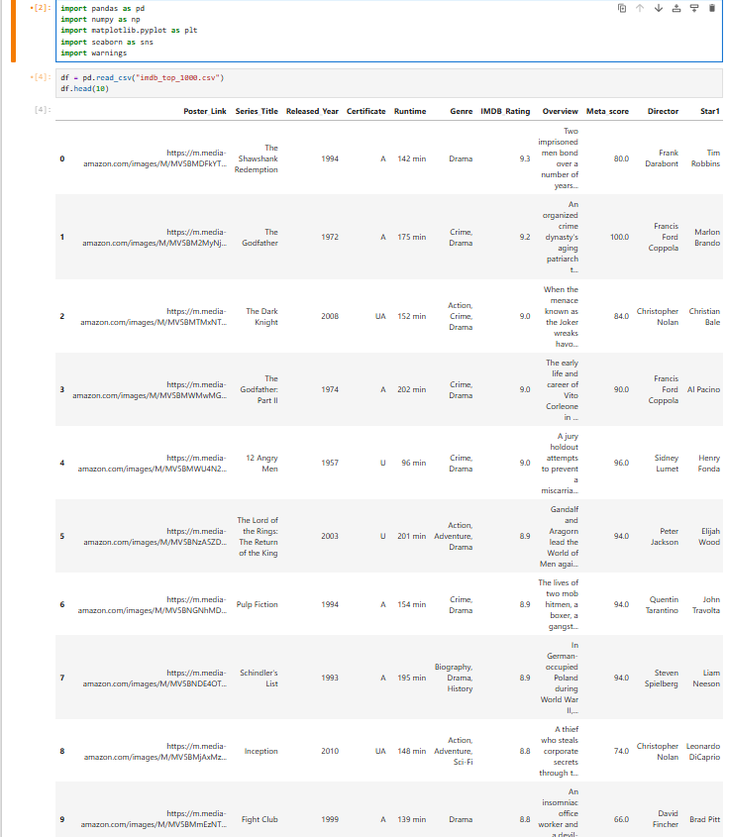

Fig no.2

- Initial Data Exploration

- Viewing dataset
- Understanding structure
- Checking missing values

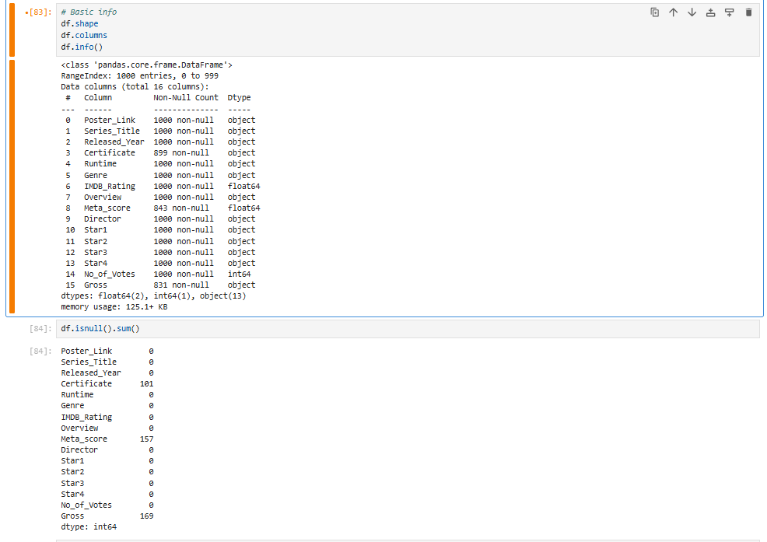

Fig no.3

- Data Preprocessing

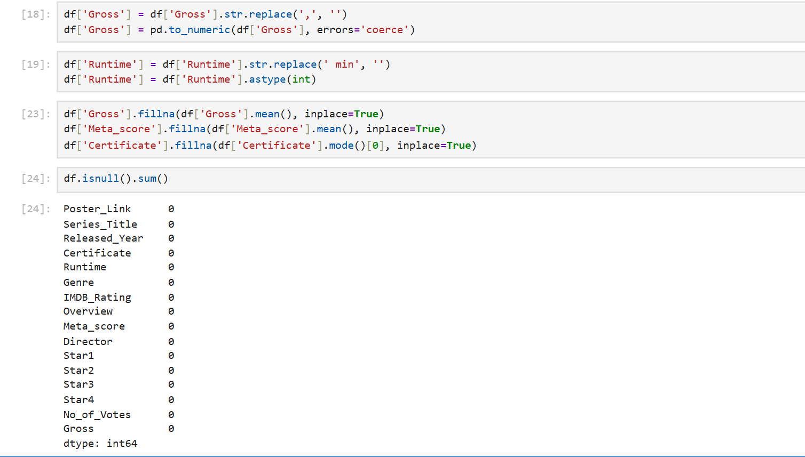

Fig no.4

- Top Rated Movies Analysis

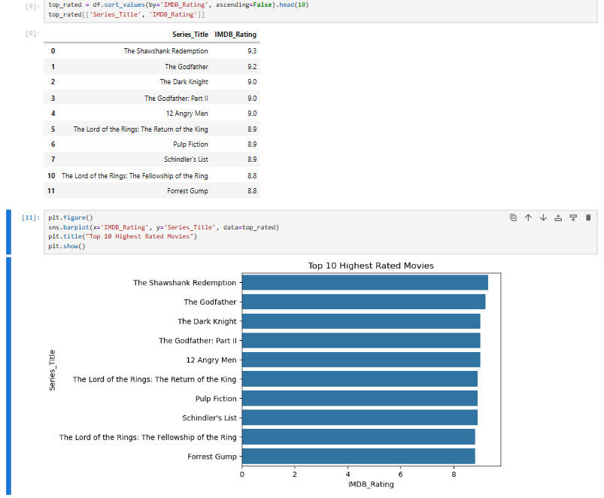

Fig no.5

- Top Actors Analysis

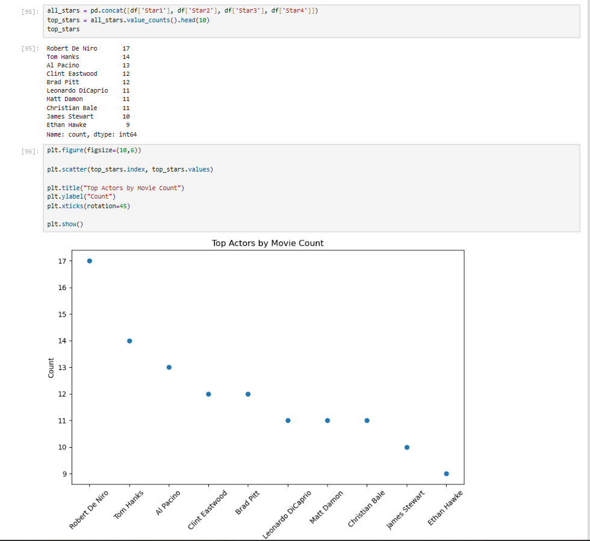

Fig no.6

- Most Popular Movies Analysis (Based on Votes)

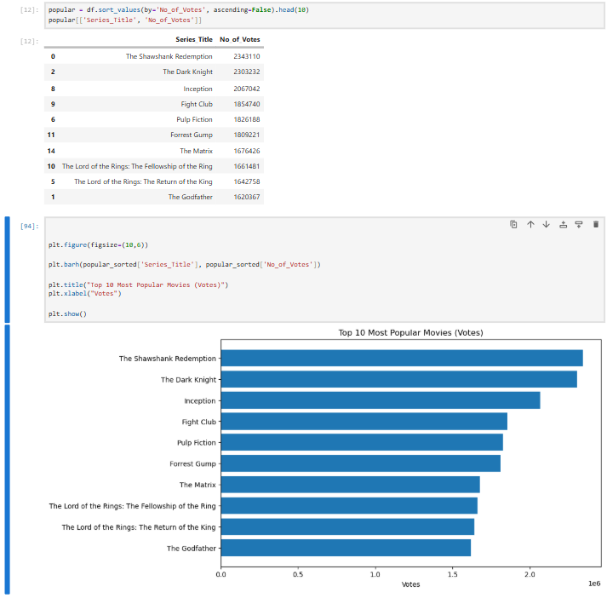

Fig no.7

- Longest Movies Analysis

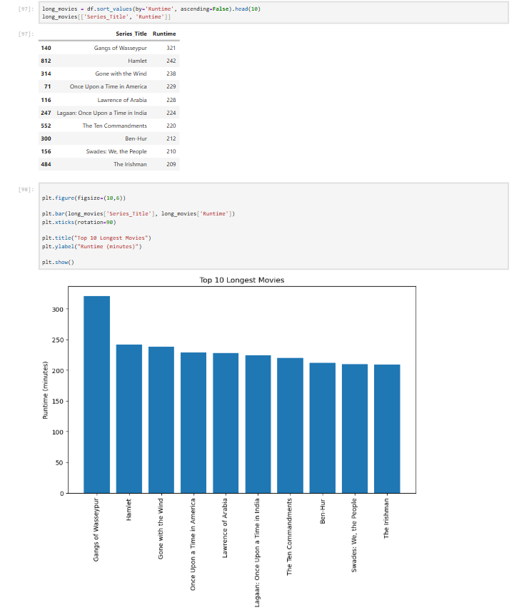
Fig no.8
- Highest Grossing Movies Analysis

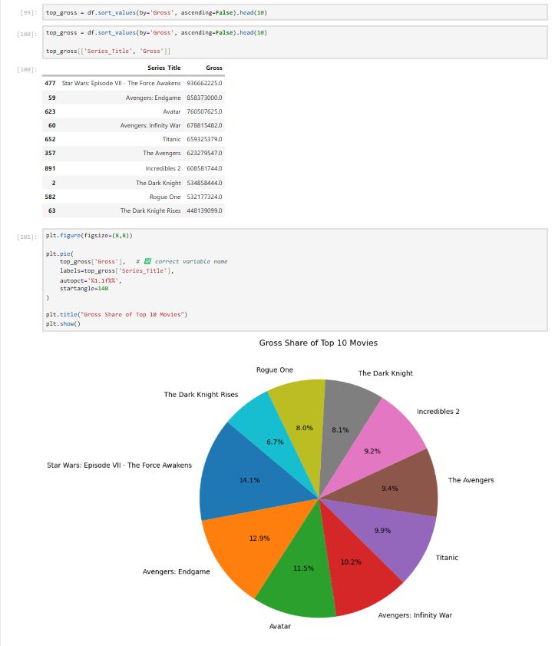

Fig no.9
- Genre Distribution Analysis

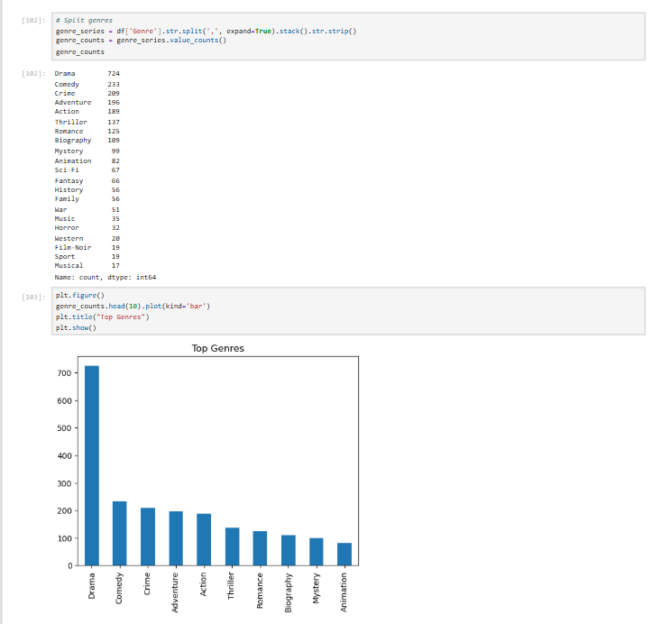

Fig no.10

- Genre-wise Rating Analysis

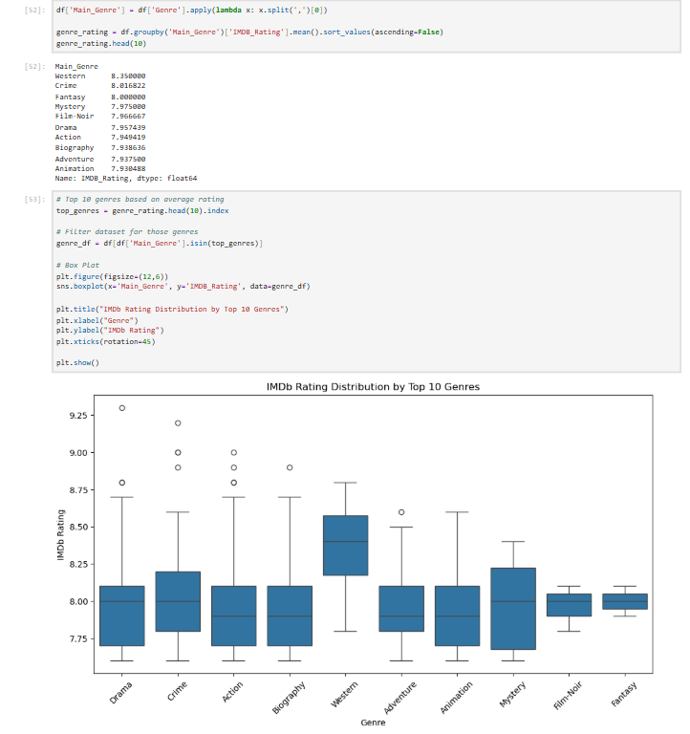
Fig no.11
- Movie Release Year Trend Analysis

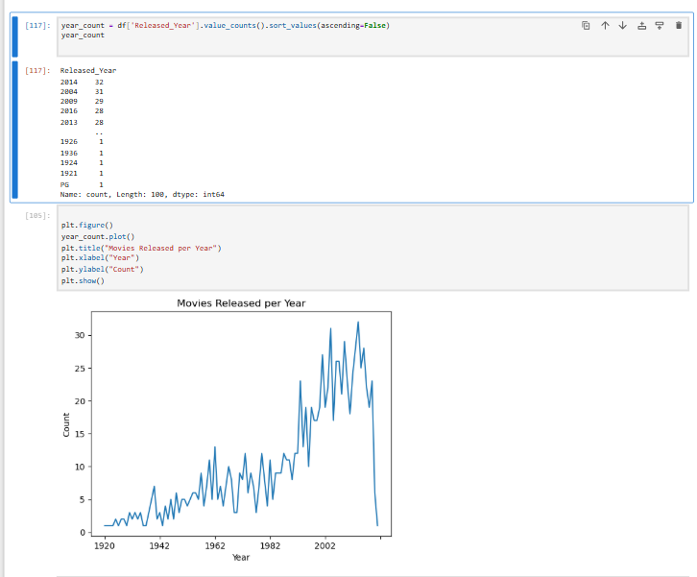

Fig no.12

- Certificate-wise Analysis

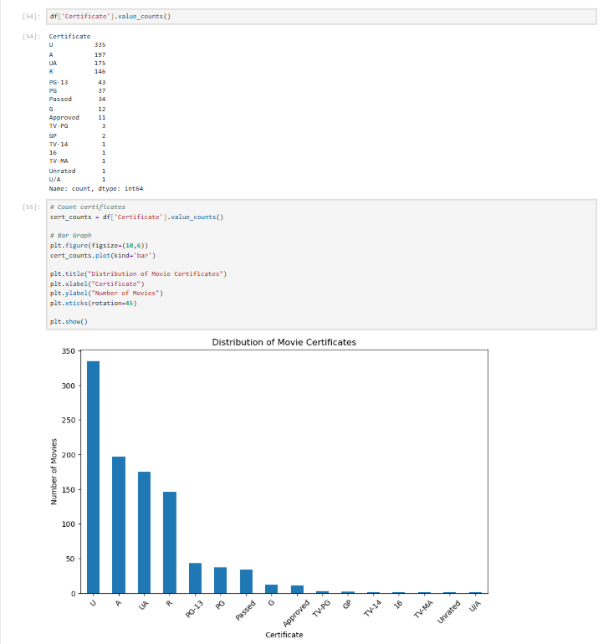

Fig no.13

- Director Analysis

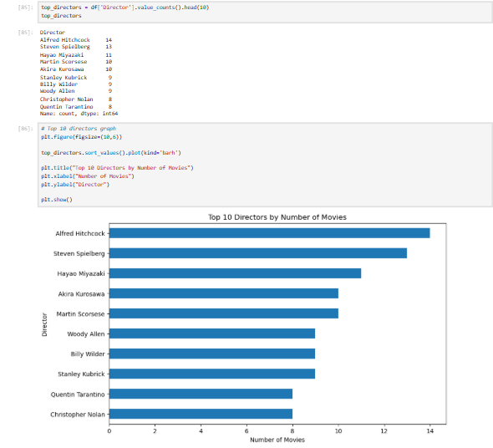

Fig no.14
- Correlation Analysis

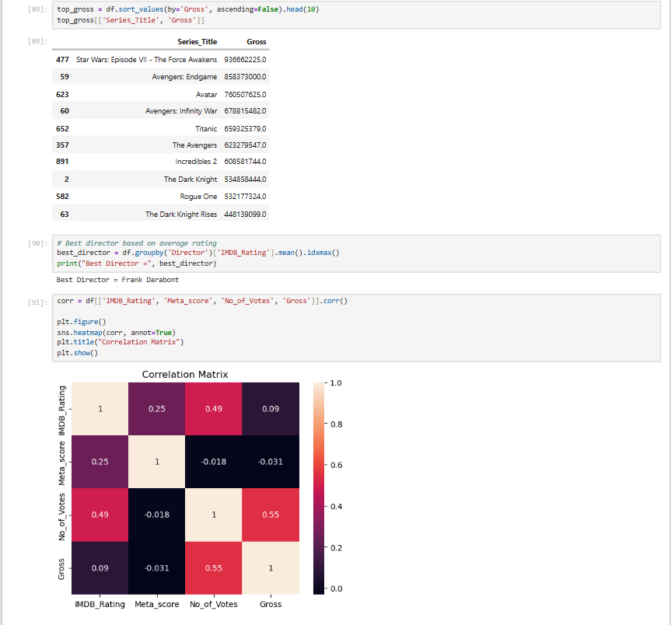

Fig no.15

5.6 REPORT ON THE ANALYSIS

- Looking at movie ratings, The Shawshank Redemption emerged as the highest-rated movie with a rating of 9.3, followed by The Godfather (9.2) and The Dark Knight (9.0).
This indicates that these films have achieved exceptional audience appreciation and critical
recognition.

- In terms of popularity based on audience votes, The Shawshank Redemption received approximately 2.34 million votes, followed by The Dark Knight (2.30 million) and Inception (2.06 million).
This shows these movies have strong audience engagement and long-lasting popularity.

- Genre analysis reveals that Drama dominates the dataset with 724 movies, followed by Comedy (233) and Crime (209).
This highlights that Drama is the most common and influential genre among top-rated movies.

- However, based on average ratings, Western ranks highest with an average rating of 8.35, followed by Crime and Fantasy.
This indicates that although Western films are fewer in number, they maintain high quality.

- Actor-level analysis shows Robert De Niro appeared most frequently with 17 movies, followed by Tom Hanks (14) and Al Pacino (13).
This suggests these actors have strong representation in critically acclaimed films.

- Director analysis shows Alfred Hitchcock directed the highest number of movies (14), followed by Steven Spielberg (13) and Hayao Miyazaki (11).
This highlights the major influence of these directors in successful cinema.

- Runtime analysis reveals Gangs of Wasseypur is the longest movie in the dataset with 321 minutes, followed by Hamlet (242 minutes) and Gone with the Wind (238 minutes).
This shows top-rated movies span a wide range of storytelling lengths.

- Gross revenue analysis indicates Star Wars: The Force Awakens generated the highest box office revenue ($936 million), followed by Avengers: Endgame ($858 million) and Avatar ($760 million).
This shows blockbuster films dominate commercial success.

- Release year analysis reveals that 2014 recorded the highest number of top movies (32 films), followed by 2004 (31) and 2009 (29).
This indicates strong representation of successful films in recent decades.

- Certificate-wise analysis shows U certification dominates with 234 movies, followed by A (197) and UA (175).
This reflects the prevalence of broadly accessible films in the dataset.

- Popularity and revenue analysis reveals a strong relationship between Number of Votes and Gross Earnings, showing that highly popular movies often generate greater revenue.
This indicates audience engagement is a major driver of commercial success.

- Correlation analysis shows:
- Strong positive relationship between Votes and Gross
- Moderate relationship between Ratings and Votes
- Weak relationship between Meta Score and other variables

This suggests popularity influences earnings more strongly than critic scores alone.
- Overall analysis shows that movie success depends not only on ratings, but also on factors such as audience engagement, genre appeal, star cast influence, and box office performance.

- One of the most significant findings from the analysis is that higher popularity tends to lead to higher gross revenue, emphasizing the importance of audience interest in determining movie success.

5.7 FINAL INSIGHTS

- The movie dataset is heavily dominated by highly rated films, with most movies having ratings above 8.0, indicating consistently high-quality content within the IMDB Top 1000.

- The Shawshank Redemption stands out as both the highest-rated (9.3) and most popular movie (2.34 million votes), making it a benchmark of critical and audience success.

- Drama is the most dominant genre with 724 movies, showing its strong presence in cinema, while Western has the highest average rating, indicating strong quality despite lower quantity.

- Actors such as Robert De Niro, Tom Hanks, and Al Pacino, along with directors like Alfred Hitchcock and Steven Spielberg, contribute significantly to the success and quality of films in the dataset.

- Commercial success is highly concentrated among blockbuster films such as Star Wars: The Force Awakens, Avengers: Endgame, and Avatar, highlighting the major contribution of high-performing films to box office revenue.

- The analysis reveals a strong positive relationship between audience votes and gross earnings, showing that popularity plays a major role in commercial success.

- Release year analysis shows a strong presence of successful films in recent decades, especially around 2004–2014, indicating growth in high-performing modern cinema.

- Although ratings are important, the analysis suggests that audience engagement and popularity influence success more strongly than ratings alone, making votes a key performance indicator.

- Correlation analysis also shows that Meta Scores have weaker influence compared to audience-driven metrics, emphasizing that audience response often matters more than critic reviews in determining success.

- Overall, the movie industry demonstrates strong connections between ratings, popularity, revenue, genre appeal, and star influence, but audience engagement emerges as the most significant factor driving success.

- Improving understanding of these patterns can help support better decision-making in areas such as movie production, marketing strategies, and audience targeting.

- In conclusion, the analysis shows that movie success is not determined by a single factor, but by a combination of quality, popularity, commercial performance, and audience interest, which together shape long-term cinematic success.

CHAPTER 6: FUTURE SCOPE AND CONCLUSION

Conclusion
From this analysis, it is clear that data plays an important role in understanding movie performance and success.

The IMDB dataset reveals that movie success is influenced by multiple factors including ratings, audience popularity, genres, and cast.

One important observation is that popularity measured through votes has a strong influence on gross revenue. This suggests audience engagement plays a major role in commercial success.

Drama dominates in quantity, while Western has the highest average rating, showing that quantity and quality can differ.

Actors like Robert De Niro and directors like Alfred Hitchcock have significant representation in successful films.

Another interesting insight is that recent years contributed many highly ranked movies, showing growth in quality cinema.

Overall, the analysis highlights that movie success is not determined only by ratings, but by a combination of popularity, revenue performance, genre appeal, and audience engagement.

Future Scope
- Apply Machine Learning models to predict movie success
- Build interactive dashboards using Microsoft Power BI or Tableau
- Perform sentiment analysis on movie reviews
- Build recommendation systems using movie features
- Use real-time streaming and audience data for advanced analysis

BIBLIOGRAPHY

- Pandas Documentation – https://docs.python.org/3/
- NumPy Documentation – https://numpy.org/doc/
- Matplotlib Documentation – https://matplotlib.org/stable/contents.html
- Seaborn Documentation – https://seaborn.pydata.org/
- IMDB Dataset - https://www.kaggle.com/datasets/harshitshankhdhar/imdb-dataset-of-top-1000-movies-and-tv-shows

CONCLUSION

This project has been an incredibly enriching journey that significantly strengthened my practical understanding of data analysis and its real-world applications. Through hands-on work with the IMDB Top 1000 Movies dataset, I developed a clearer perspective on how data can be used to analyze movie performance, understand audience behavior, and evaluate factors influencing success.
Working with a structured movie dataset allowed me to sharpen my skills in data cleaning, preprocessing, exploratory data analysis, and visualization. I gained practical experience in transforming raw data into meaningful insights by analyzing trends across ratings, genres, actors, directors, popularity, and box office earnings. This process enhanced my ability to handle real-world data challenges and extract valuable insights from complex datasets.
Beyond technical skills, this project improved my analytical thinking and problem-solving abilities. I learned how to interpret patterns in data, identify key factors affecting movie success, and connect insights to real-world industry scenarios. For instance, understanding the relationship between audience votes and gross earnings, along with identifying genre and release year trends, helped me appreciate how data can reveal meaningful patterns and support informed decisions.
Additionally, the project strengthened my ability to communicate findings effectively. By presenting insights through clear visualizations and structured reporting, I developed the skill of explaining complex data in a simple and understandable manner, making it accessible even to non-technical audiences.
Overall, this project has reinforced my interest in the field of data science and analytics. The practical exposure and experience gained have equipped me with confidence and foundational skills required to grow further and contribute effectively in a data-driven environment.
REMARKS

This is to certify that Mr. Shivakanth V has successfully completed the project titled “IMDB Top 1000 Movies Analysis using Python” as part of his academic work. During the course of this project, he worked sincerely and contributed meaningfully to all phases of data collection, preprocessing, analysis, visualization, and insight generation.
He displayed excellent enthusiasm and a strong willingness to learn and apply data analytics concepts in a practical environment. He approached the project with dedication and professionalism, and demonstrated the ability to understand analytical concepts and implement them effectively using Python tools.
Throughout the project, he showed good analytical thinking, problem-solving ability, and technical competence in handling real-world data. His work on identifying patterns related to movie ratings, popularity, genres, actors, directors, and revenue reflects a strong understanding of data analysis techniques.
He completed the project successfully and presented the findings in a clear and structured manner. His performance during this project reflects both technical capability and a positive learning attitude.
We believe he possesses the skills and potential to excel in his future academic and professional journey, and we wish him continued success in all his future endeavors.
AYSHATH LUBNA
Internship Program Head



